**Glick & Woods Easter Egg Hunt 2022**

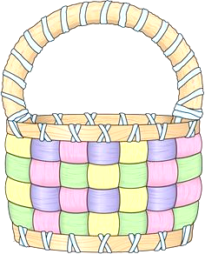****

**Ages 3-10 (Children must be able to hunt eggs on their own)**

**Don’t forget their baskets!!!**

**Saturday**

**April 9th, 2022**

**Time- 10:00AM**

**SHARP**

Dr. Kim Glick, Dr. Larry Woods, & staff will be sponsoring their 39TH Annual Easter Egg Hunt for children of Tullahoma and surrounding areas.

This year’s egg hunt will be at Frazier McEwen Park.